**Cheetah Access Document:**

**Access Via My Logins: SI-AUTO, LPL – BCM, LPL Pricer (TCG)**

[https://mylogins.cso.att.com](https://mylogins.cso.att.com/)

New login request

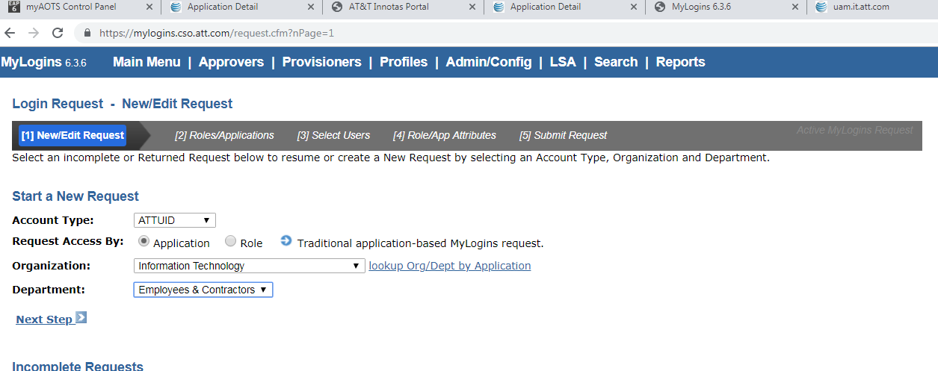

Select Org: IT

Dept: Employees & contracts

Next>> select the Application as SI-Auto, LPL – BCM, LPL Pricer (TCG)

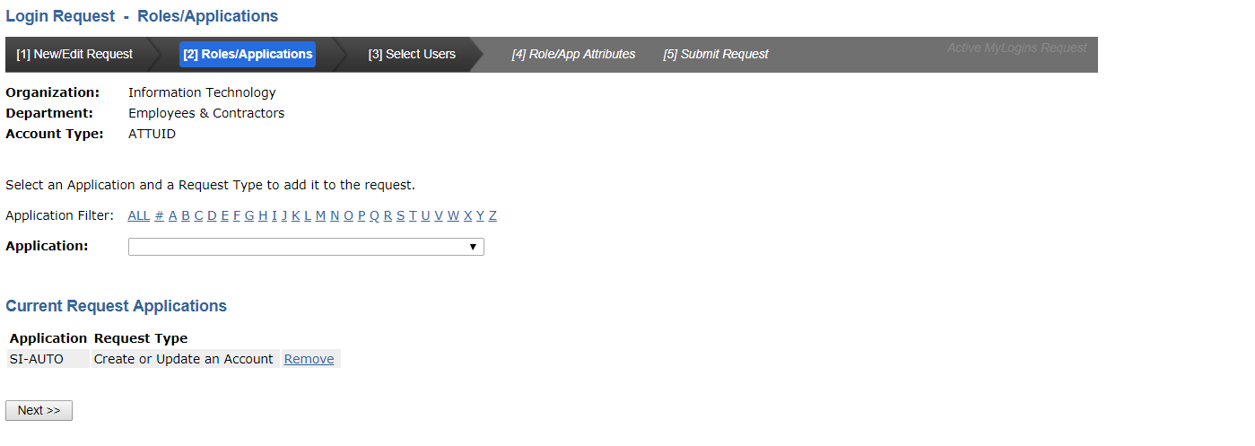

Insert ID

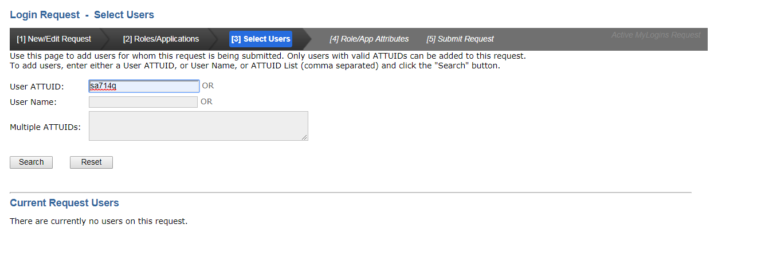

Select the highlighted Application: only for SI-Auto

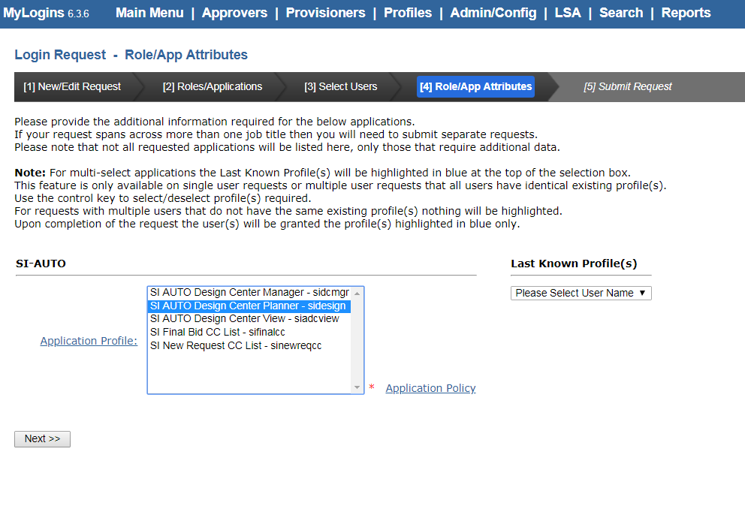

Mention the handling information

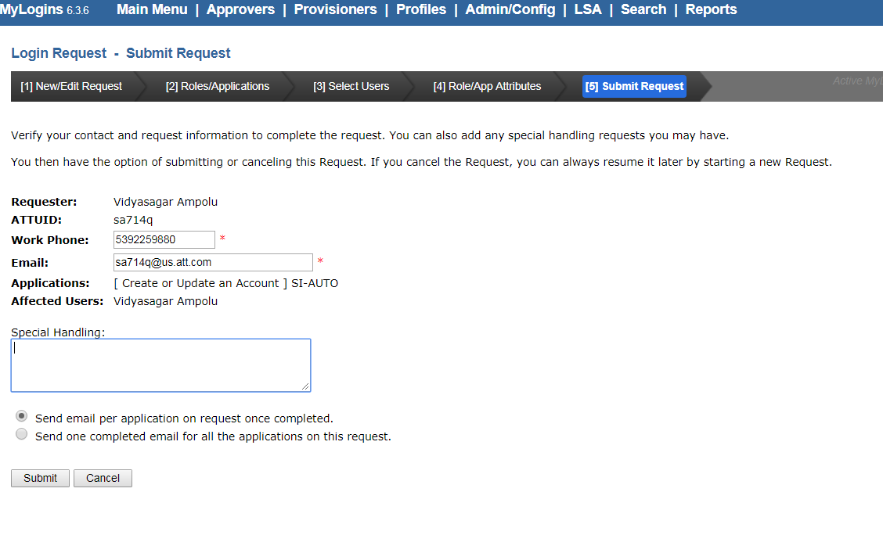

& submit.

UAM for DSNP Application:

<http://uam.it.att.com/>

search for DSNP application

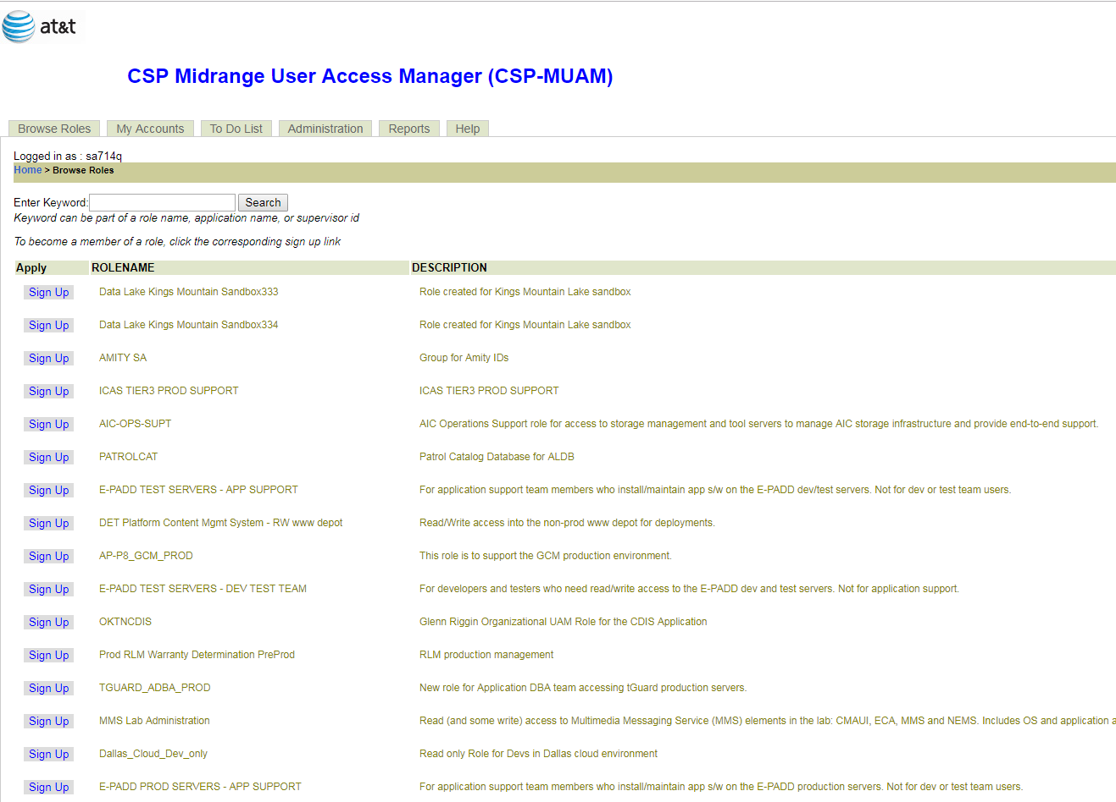

Select DSNP – BOA support

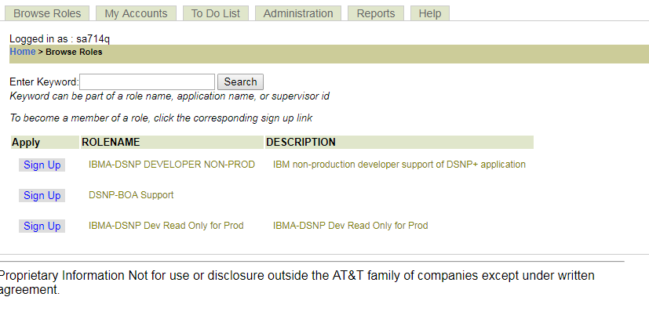

Enter the required details, business reason and click on submit

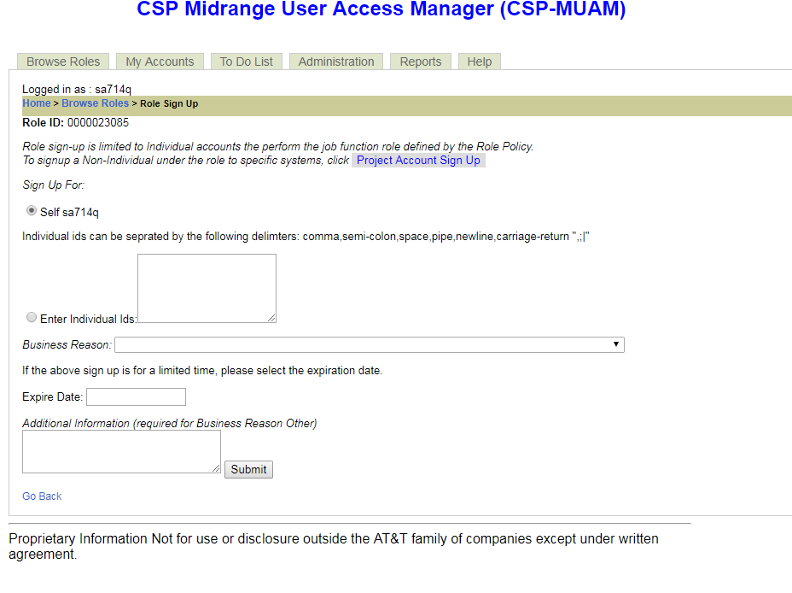

SPS Application:

<http://ushportal.it.att.com/step3.cfm?app=2065&prob=34802&subprob=0&home=ush&bypass_selfhelp=1&bypass_outage=1>

we need to create a RACF ticket for access to SPS production system

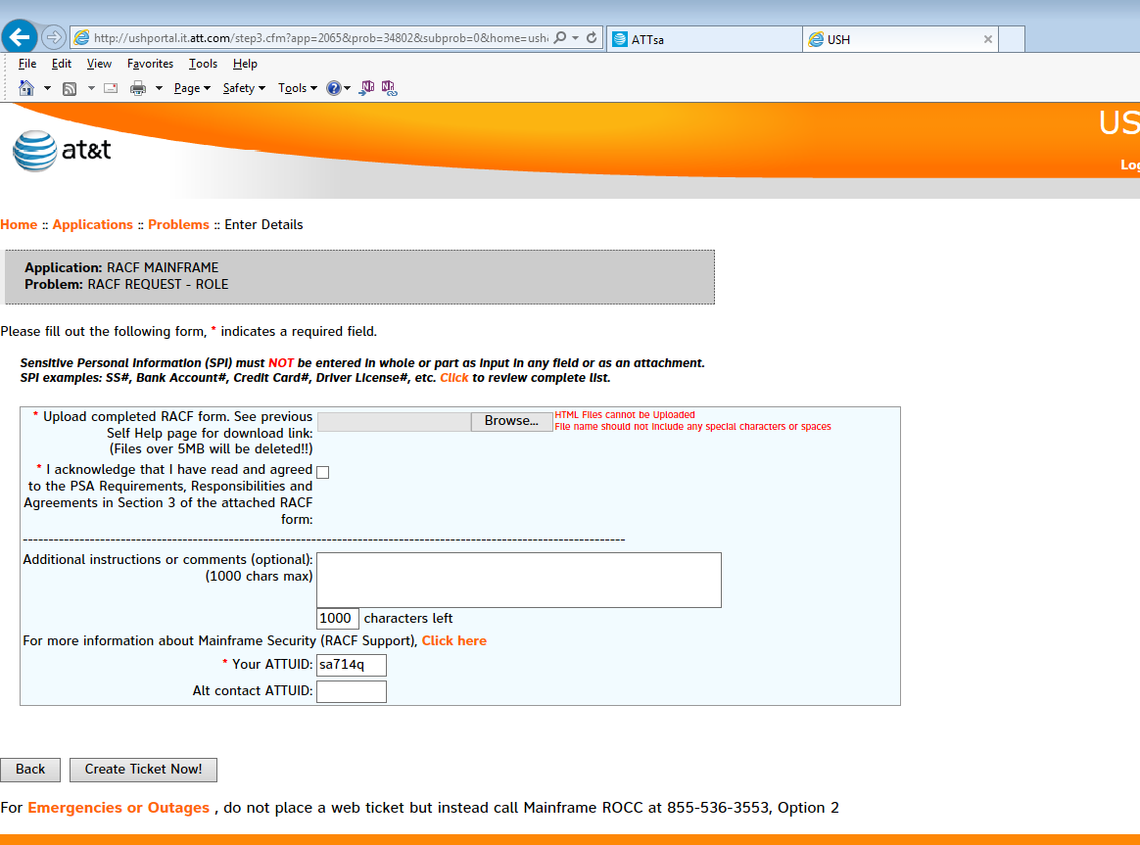

Need to enter all the required information in the page. And upload the RACF Form.

<https://intra4.web.att.com/attsa/index.cfm>

Sample Emails:

